**MULTIPLEXER (16:1)**

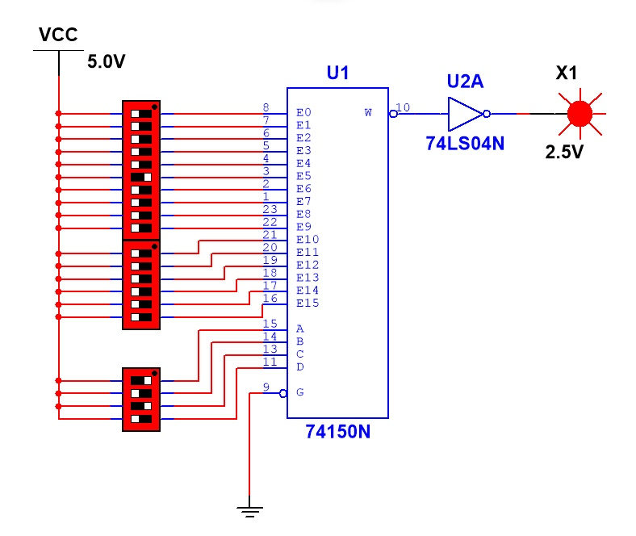

|  |  |  |  |  |
| --- | --- | --- | --- | --- |
| **TRUTH TABLE** | | | | |
| **Inputs** | | | | **Output** |
| **S3** | **S2** | **S1** | **S0** | **Y** |
| 0 | 0 | 0 | 0 | I0 |
| 0 | 0 | 0 | 1 | I1 |
| 0 | 0 | 1 | 0 | I2 |
| 0 | 0 | 1 | 1 | I3 |
| 0 | 1 | 0 | 0 | I4 |
| 0 | 1 | 0 | 1 | I5 |
| 0 | 1 | 1 | 0 | I6 |
| 0 | 1 | 1 | 1 | I7 |
| 1 | 0 | 0 | 0 | I8 |
| 1 | 0 | 0 | 1 | I9 |
| 1 | 0 | 1 | 0 | I10 |
| 1 | 0 | 1 | 1 | I11 |
| 1 | 1 | 0 | 0 | I12 |
| 1 | 1 | 0 | 1 | I13 |
| 1 | 1 | 1 | 0 | I14 |
| 1 | 1 | 1 | 1 | I15 |

**MULTIPLEXER**

A multiplexer (MUX) is a device allowing one or more low-speed analog or digital input signals to be selected, combined and transmitted at a higher speed on a single shared medium or within a single shared device. Thus, several signals may share a single device or transmission conductor such as a copper wire or fiber optic cable. A MUX functions as a multiple-input, single-output switch.

In telecommunications the combined signals, analog or digital, are considered a single-output higher-speed signal transmitted on several communication channels by a particular multiplex method or technique. With two input signals and one output signal, the device is referred to as a 2-to-1 multiplexer; with four input signals it is a 4-to-1 multiplexer, with sixteen input signals it is a 16-to-1 multiplexer; etc.

**DEMULTIPLEXER (1:16)**

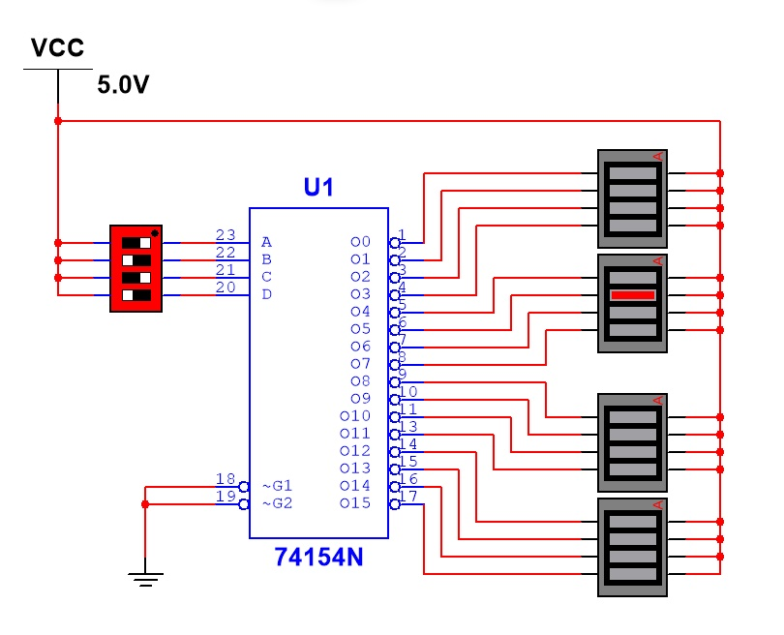

|  |  |  |  |  |  |  |  |  |  |  |  |  |  |  |  |  |  |  |  |
| --- | --- | --- | --- | --- | --- | --- | --- | --- | --- | --- | --- | --- | --- | --- | --- | --- | --- | --- | --- |
| **TRUTH TABLE** | | | | | | | | | | | | | | | | | | | |
| **INPUTS** | | | | **OUTPUTS** | | | | | | | | | | | | | | | |
| 0 | 0 | 0 | 0 | 0 | 1 | 1 | 1 | 1 | 1 | 1 | 1 | 1 | 1 | 1 | 1 | 1 | 1 | 1 | 1 |
| 0 | 0 | 0 | 1 | 1 | 0 | 1 | 1 | 1 | 1 | 1 | 1 | 1 | 1 | 1 | 1 | 1 | 1 | 1 | 1 |
| 0 | 0 | 1 | 0 | 1 | 1 | 0 | 1 | 1 | 1 | 1 | 1 | 1 | 1 | 1 | 1 | 1 | 1 | 1 | 1 |
| 0 | 0 | 1 | 1 | 1 | 1 | 1 | 0 | 1 | 1 | 1 | 1 | 1 | 1 | 1 | 1 | 1 | 1 | 1 | 1 |
| 0 | 1 | 0 | 0 | 1 | 1 | 1 | 1 | 0 | 1 | 1 | 1 | 1 | 1 | 1 | 1 | 1 | 1 | 1 | 1 |
| 0 | 1 | 0 | 1 | 1 | 1 | 1 | 1 | 1 | 0 | 1 | 1 | 1 | 1 | 1 | 1 | 1 | 1 | 1 | 1 |
| 0 | 1 | 1 | 0 | 1 | 1 | 1 | 1 | 1 | 1 | 0 | 1 | 1 | 1 | 1 | 1 | 1 | 1 | 1 | 1 |
| 0 | 1 | 1 | 1 | 1 | 1 | 1 | 1 | 1 | 1 | 1 | 0 | 1 | 1 | 1 | 1 | 1 | 1 | 1 | 1 |
| 1 | 0 | 0 | 0 | 1 | 1 | 1 | 1 | 1 | 1 | 1 | 1 | 0 | 1 | 1 | 1 | 1 | 1 | 1 | 1 |
| 1 | 0 | 0 | 1 | 1 | 1 | 1 | 1 | 1 | 1 | 1 | 1 | 1 | 0 | 1 | 1 | 1 | 1 | 1 | 1 |
| 1 | 0 | 1 | 0 | 1 | 1 | 1 | 1 | 1 | 1 | 1 | 1 | 1 | 1 | 0 | 1 | 1 | 1 | 1 | 1 |
| 1 | 0 | 1 | 1 | 1 | 1 | 1 | 1 | 1 | 1 | 1 | 1 | 1 | 1 | 1 | 0 | 1 | 1 | 1 | 1 |
| 1 | 1 | 0 | 0 | 1 | 1 | 1 | 1 | 1 | 1 | 1 | 1 | 1 | 1 | 1 | 1 | 0 | 1 | 1 | 1 |
| 1 | 1 | 0 | 1 | 1 | 1 | 1 | 1 | 1 | 1 | 1 | 1 | 1 | 1 | 1 | 1 | 1 | 0 | 1 | 1 |
| 1 | 1 | 1 | 0 | 1 | 1 | 1 | 1 | 1 | 1 | 1 | 1 | 1 | 1 | 1 | 1 | 1 | 1 | 0 | 1 |
| 1 | 1 | 1 | 1 | 1 | 1 | 1 | 1 | 1 | 1 | 1 | 1 | 1 | 1 | 1 | 1 | 1 | 1 | 1 | 0 |

**DEMULTIPLEXER**

A demultiplexer (or demux) is a device that takes a single input line and routes it to one of several digital output lines. A demultiplexer of 2n outputs has n select lines, which are used to select which output line to send the input. A demultiplexer is also called a data distributor.

Demultiplexers can be used to implement general purpose logic. By setting the input to true, the demux behaves as a decoder.

The reverse of the digital demultiplexer is the digital multiplexer

**ENCODER (8 TO 3)**

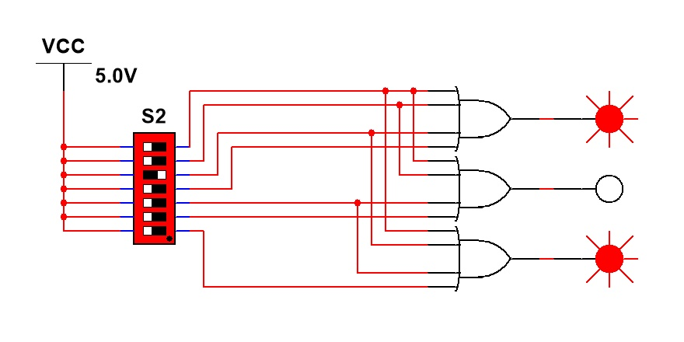

|  |  |  |  |  |  |  |  |  |  |  |
| --- | --- | --- | --- | --- | --- | --- | --- | --- | --- | --- |
| **TRUTH TABLE** | | | | | | | | | | |
| **INPUT** | | | | | | | | **OUTPUT** | | |
| 1 | 0 | 0 | 0 | 0 | 0 | 0 | 0 | 0 | 0 | 0 |
| 0 | 1 | 0 | 0 | 0 | 0 | 0 | 0 | 0 | 0 | 1 |
| 0 | 0 | 1 | 0 | 0 | 0 | 0 | 0 | 0 | 1 | 0 |
| 0 | 0 | 0 | 1 | 0 | 0 | 0 | 0 | 0 | 1 | 1 |
| 0 | 0 | 0 | 0 | 1 | 0 | 0 | 0 | 1 | 0 | 0 |
| 0 | 0 | 0 | 0 | 0 | 1 | 0 | 0 | 1 | 0 | 1 |
| 0 | 0 | 0 | 0 | 0 | 0 | 1 | 0 | 1 | 1 | 0 |
| 0 | 0 | 0 | 0 | 0 | 0 | 0 | 1 | 1 | 1 | 1 |

**ENCODER**

An encoder is a device, circuit, transducer, software program, algorithm or person that converts information from one format or code to another, for the purpose of standardization, speed or compression.

**DECODER (3 TO 8)**

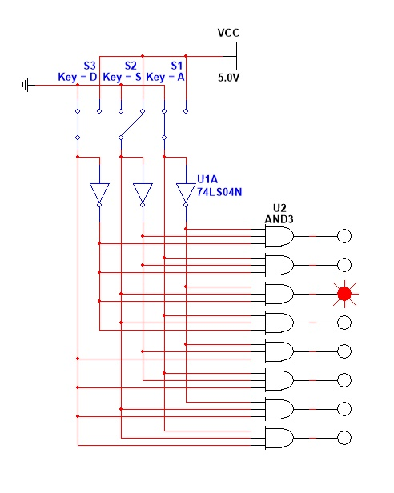

|  |  |  |  |  |  |  |  |  |  |  |
| --- | --- | --- | --- | --- | --- | --- | --- | --- | --- | --- |
| **TRUTH TABLE** | | | | | | | | | | |
| **OUTPUT** | | | **INPUT** | | | | | | | |
| 0 | 0 | 0 | 1 | 0 | 0 | 0 | 0 | 0 | 0 | 0 |
| 0 | 0 | 1 | 0 | 1 | 0 | 0 | 0 | 0 | 0 | 0 |
| 0 | 1 | 0 | 0 | 0 | 1 | 0 | 0 | 0 | 0 | 0 |
| 0 | 1 | 1 | 0 | 0 | 0 | 1 | 0 | 0 | 0 | 0 |
| 1 | 0 | 0 | 0 | 0 | 0 | 0 | 1 | 0 | 0 | 0 |
| 1 | 0 | 1 | 0 | 0 | 0 | 0 | 0 | 1 | 0 | 0 |
| 1 | 1 | 0 | 0 | 0 | 0 | 0 | 0 | 0 | 1 | 0 |
| 1 | 1 | 1 | 0 | 0 | 0 | 0 | 0 | 0 | 0 | 1 |

**DECODER**

In digital electronics, a decoder can take the form of a multiple-input, multiple-output logic circuit that converts coded inputs into coded outputs, where the input and output codes are different e.g. n-to-2n , binary-coded decimal decoders. Decoding is necessary in applications such as data multiplexing, 7 segment display and memory address decoding.

A slightly more complex decoder would be the n-to-2n type binary decoders. These types of decoders are combinational circuits that convert binary information from 'n' coded inputs to a maximum of 2n unique outputs. In case the 'n' bit coded information has unused bit combinations, the decoder may have less than 2n outputs. 2-to-4 decoder, 3-to-8 decoder or 4-to-16 decoder are other examples.

**PARITY CHECKER/GENERATOR**

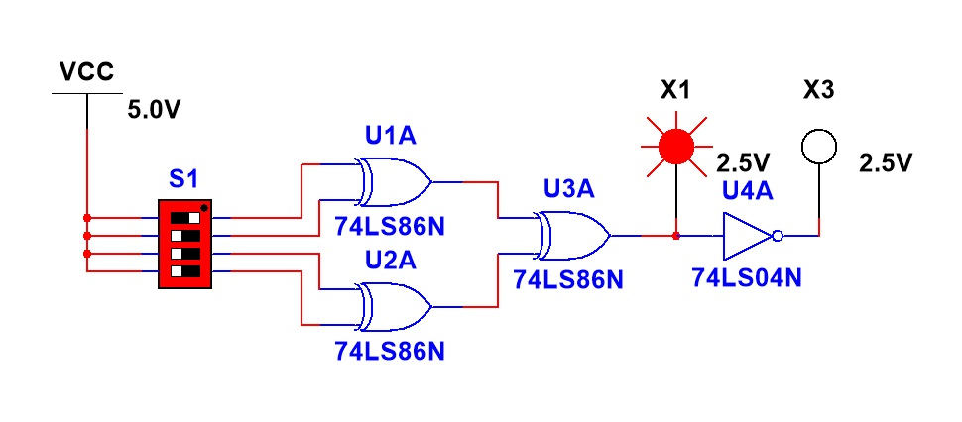

|  |  |  |  |  |
| --- | --- | --- | --- | --- |
| **TRUTH TABLE** | | | | |
| **INPUT** | | | | **OUTPUT** |
| 0 | 0 | 0 | 0 | 0 |
| 0 | 0 | 0 | 1 | 1 |
| 0 | 0 | 1 | 0 | 1 |
| 0 | 0 | 1 | 1 | 0 |
| 0 | 1 | 0 | 0 | 1 |
| 0 | 1 | 0 | 1 | 0 |
| 0 | 1 | 1 | 0 | 0 |
| 0 | 1 | 1 | 1 | 1 |
| 1 | 0 | 0 | 0 | 1 |
| 1 | 0 | 0 | 1 | 0 |
| 1 | 0 | 1 | 0 | 0 |
| 1 | 0 | 1 | 1 | 1 |
| 1 | 1 | 0 | 0 | 0 |
| 1 | 1 | 0 | 1 | 1 |
| 1 | 1 | 1 | 0 | 1 |
| 1 | 1 | 1 | 1 | 0 |

**PARITY CHECKER/GENERATOR**

A parity generator is a combinational logic circuit that generates the parity bit in the transmitter. On the other hand, a circuit that checks the parity in the receiver is called parity checker. A combined circuit or devices of parity generators and parity checkers are commonly used in digital systems to detect the single bit errors in the transmitted data word.

The sum of the data bits and parity bits can be even or odd . In even parity, the added parity bit will make the total number of 1s an even amount whereas in odd parity the added parity bit will make the total number of 1s odd amount.

The basic principle involved in the implementation of parity circuits is that sum of odd number of 1s is always 1 and sum of even number of 1s is always zero. Such error detecting and correction can be implemented by using Ex-OR gates (since Ex-OR gate produce zero output when there are even number of inputs).

**1 –BIT COMPARATOR**

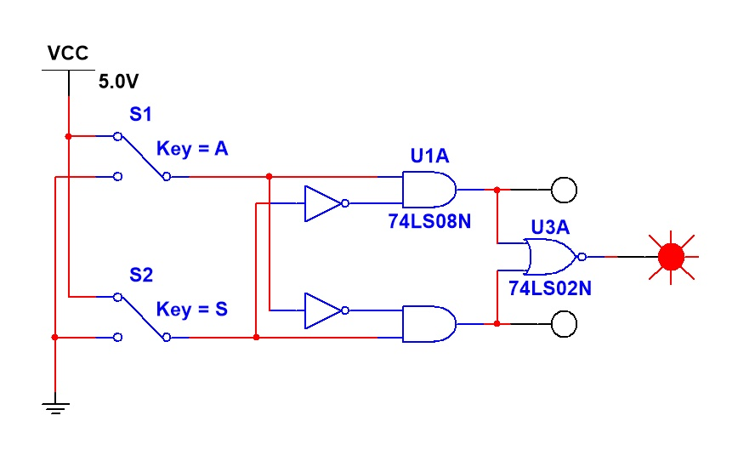

|  |  |  |  |  |
| --- | --- | --- | --- | --- |
| **TRUTH TABLE** | | | | |
| **A** | **B** | **A>B** | **A=B** | **A<B** |
| 0 | 0 | 0 | 1 | 0 |
| 0 | 1 | 0 | 0 | 1 |
| 1 | 0 | 1 | 0 | 0 |
| 1 | 1 | 0 | 1 | 0 |

**COMPARATOR**

A magnitude digital Comparator is a combinational circuit that compares two digital or binary numbers in order to find out whether one binary number is equal, less than or greater than the other binary number. We logically design a circuit for which we will have two inputs one for A and other for B and have three output terminals, one for A > B condition, one for A = B condition and one for A < B condition.

A comparator used to compare two bits is called a single bit comparator. It consists of two inputs each for two single bit numbers and three outputs to generate less than, equal to and greater than between two binary numbers.